**WEEK – 8**

**1#** If a 5-digit number is entered from keyboard. Write a program to print a new number by adding one to each of its digit. For example, for digit 12991 we get the output 23002.

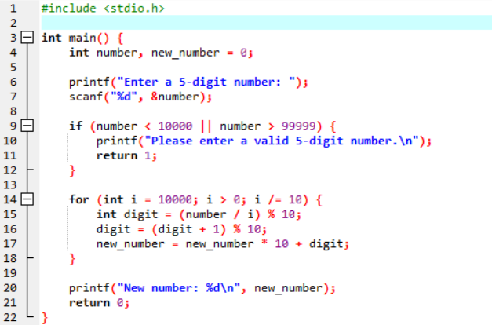

* The for loop runs 5 times (since the number has 5 digits).
* Each iteration extracts the last digit of the number, increments it by 1, and adjusts for wrapping from 9 to 0.
* It then forms the new number, just like in the while loop version.
* After processing all 5 digits, the new number is printed.

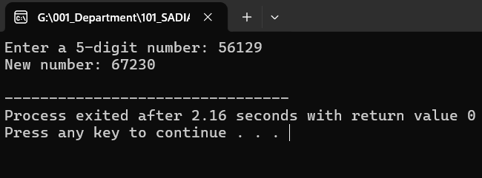

**2#** Write a program to print a list of prime numbers between a given ranges which you entered from the keyboard

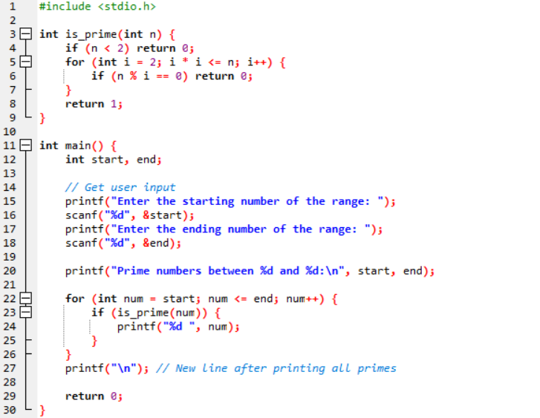

* **is_prime(int n)**: A function that checks if n is a prime number.
* The main function prompts the user for a start and end value.
* It iterates through the range and prints each prime number.

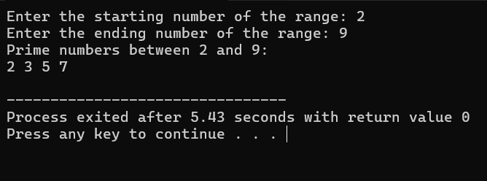

**3#** Write an interactive program in C to find the factorial of a given integer.

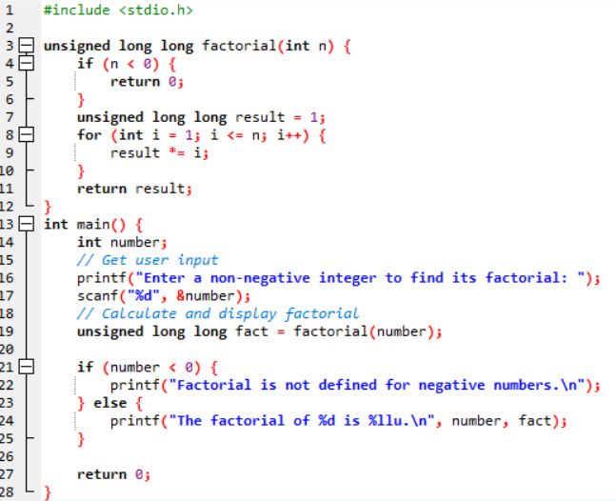

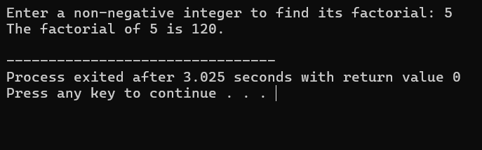

**4#** Write a C program that prints shape giving below by using nested loop:  
 1  
 1 2  
 1 2 3  
 1 2 3 4  
 1 2 3 4 5

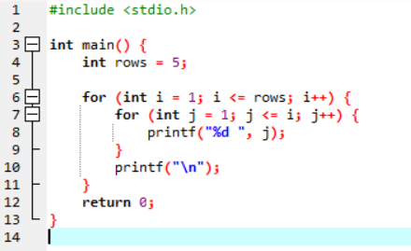  
  
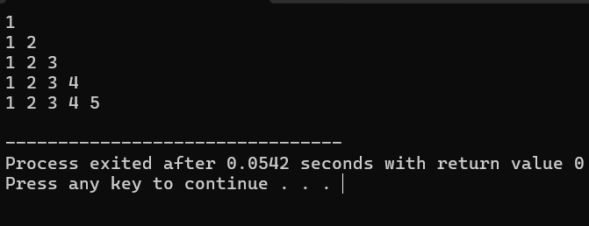

**5#** Write a program to find the LCM (lowest common divisor) and HCF (Highest Common Factor) of entered two numbers.

